To run the sample program, follow the guidelines.

hadoop fs -copyFromLocal SampleImages
(SampleImages being the local FS folder where the images are stored)
This command will create the folder SampleImages in HDFS.

Note: Don’t create a folder in HDFS first (or providing the new HDFS folder in above command) and then run the above command. Doing so will not properly execute the program.

For eg, SampleImages contains following three files:

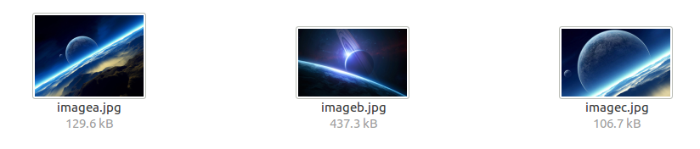

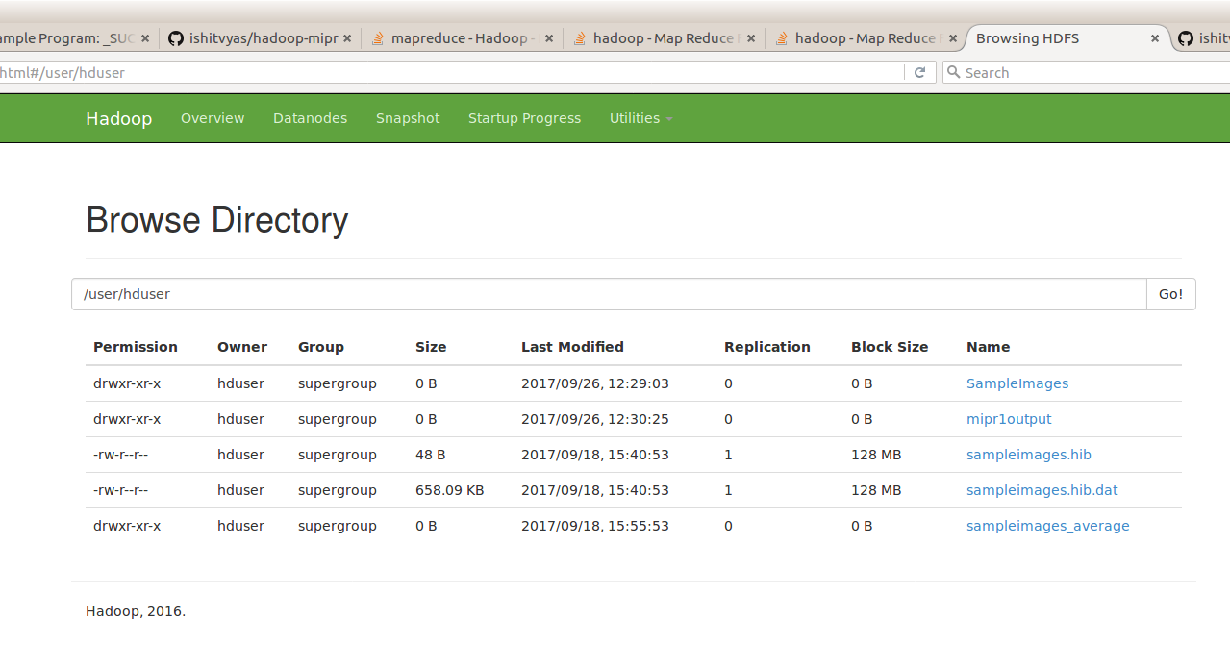

Image: HDFS

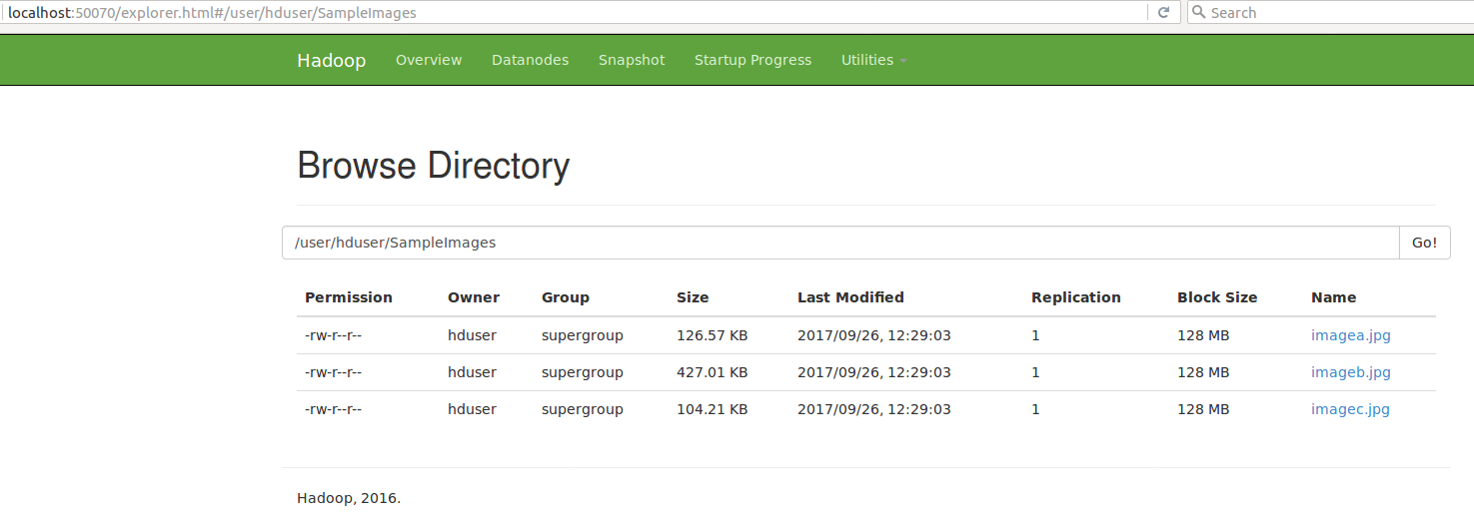
Image: SampleImages in HDFS

Run following from the path of mipr-core-0.1-jar-with-dependencies.jar

hadoop jar mipr-core-0.1-jar-with-dependencies.jar experiments.Img2Gray SampleImages mipr1output

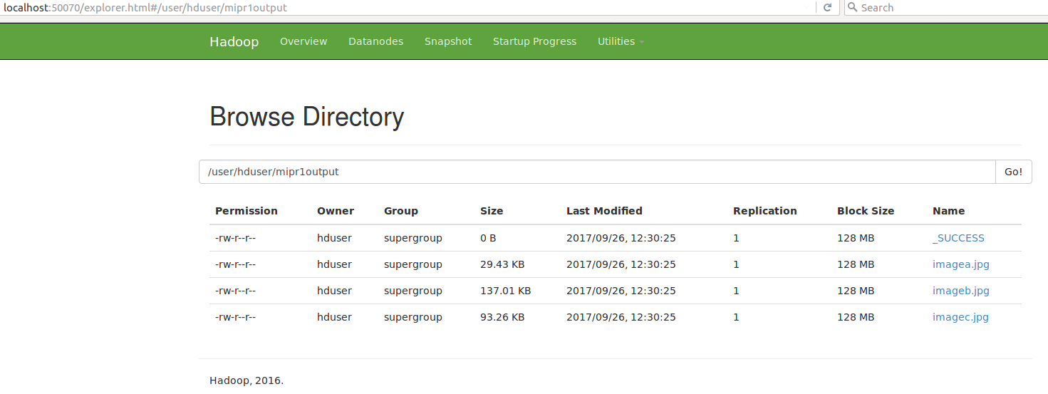
Image: Output in HDFS

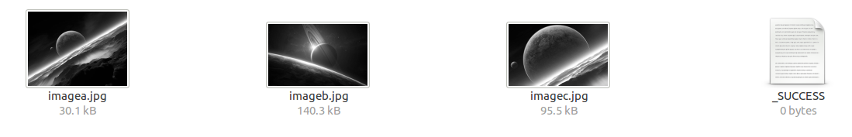
Image: Output images (Converted to Greyscale)

